Packing
Jerome K. Jerome

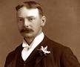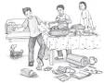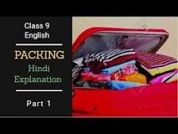

This story is an extract from Jerome K. Jerome's novel 'Three Men in a Boat'. The narrator of the story and his two friends decided to go on a holiday. The question of packing the things for the journey arose. The author thought that he was an expert in packing.
George and Harris offer to pack because it was getting late and they thought Jerome had taken too much of time. They also want to show their skill to Jerome .The narrator volunteers the packing because he thought he was the best packer, he feel proud on his packing and wanted to show it.
Jerome had to reopen the packed bag twice because of his forgetfulness. Once he had to reopen the bag as he had forgotten to pack the boots. The next time, he unpacked when he realized he had packed his tobacco-pouch in.
Jerome says Montmorency's ambition in life was to disturb people while they are working and be sworn at. Montmorency was a little dog, who always loved to trouble others. ... A dog like Montmorency never wanted any encouragement. He was born with such a nature that made him do things like that.
Characters: 1. Narrator 2. George 3. Harris. 4. Montmorency.

